Roasted Dandelion Mocha

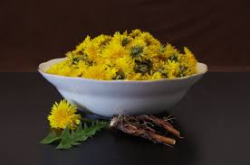
Image by Pexels

1-3 servings
5 min. prep time
30 min. cook time

- 3-4 cups Biocera or filtered water
- 3-4 T Roasted dandelion root
- 1 T Raw cacao nibs or cacao chocolate
- 1 T Raw ghee, butter or coconut oil
- ½ T cinnamon chips
- ½ tsp cardamom pods
- ¼ tsp clove root
- ½ cup coconut milk or substitute
- 1 T stevia or choice sweetener (i.e. raw honey, maple syrup, etc)
- ½ tsp vanilla extract
- A dash of nutmeg

- Decoct the roasted dandelion rt, cacao nibs and cinnamon chips in water with the lid on allowing the mixture to simmer for 30 minutes.
- Remove from heat and strain spent herbs. Allow to cool for 5-10 minutes.
- Once cool enough add the remaining ingredients: ghee, coconut milk, stevia, vanilla extract and nutmeg.
- Use an immersion hand blender or blender to froth the substance to liking. Enjoy!

Tips:
- This recipe aids folks weaning off coffee or trying to lower consumption.
- Chicory also pairs well with dandelion providing the stimulating, bitter tastiness that coffee offers to coffee lovers. *Warning: chicory is also high in prebiotic fiber, therefore it may cause gastrointestinal distress for those who have dysbiosis.
- If you still need a buzz you can mix in small amounts of coffee.

