CHAI COLLAGEN BLISS BALLS
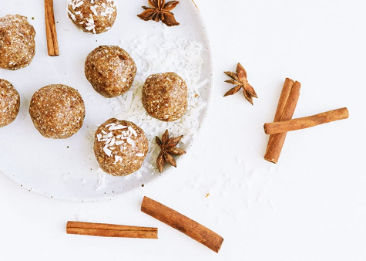
30 minutes
10 - 15 bites

- 1 cup almond flour
- 2 scoops Perfect Supplements Collagen
- 12 Medjool dates, pitted
- 1/4 cup almond milk
- 1 tablespoon raw honey or maple syrup
- ¼ cup shredded coconut (plus extra for rolling)
- 1 teaspoon pure organic vanilla extract
- 1/4 teaspoon sea salt
- 1 teaspoon cinnamon
- 1/2 teaspoon ginger
- 1/2 teaspoon cardamom
- 1/4 teaspoon Chinese five spice
- 1/4 teaspoon cloves
- 1/4 teaspoon allspice

- Add almond flour, protein powder, shredded coconut, salt, and spices to your large bowl and mix well.
- Add dry ingredients to your food processor, then add wet ingredients.
- Pulse until the mix becomes a crumbly texture, yet holds together when you press it between your fingers.
- Roll mixture into small balls, then (optional) roll into shredded coconut or even crushed nuts of your choice.
- Place on a plate and let set in the fridge for 15 minutes before serving.

Tips:
- Collagen Peptides are an easy way to increase the nutrient density of any recipe! Turn everything from smoothies to baked goods into anti-aging, gut-healing superfoods with just one flavor-free scoop.

